University of Anbar
Faculty of Management and Economics
Administrative and Economic Advisory Office
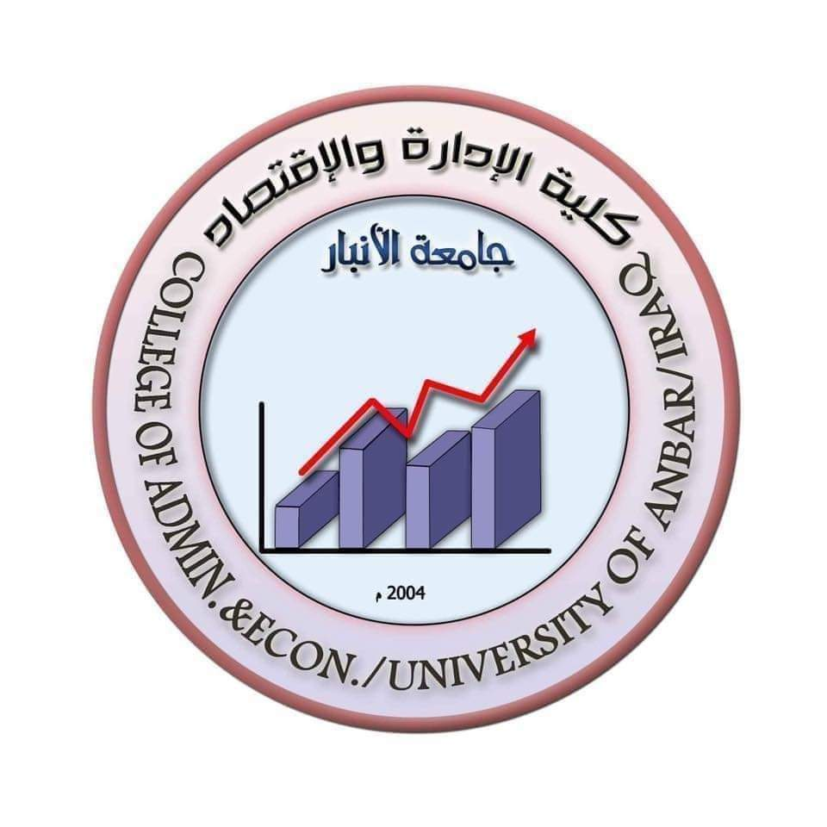

Head of Administrative and Economic Advisory Office
Dr. Faais of Hilil Sarih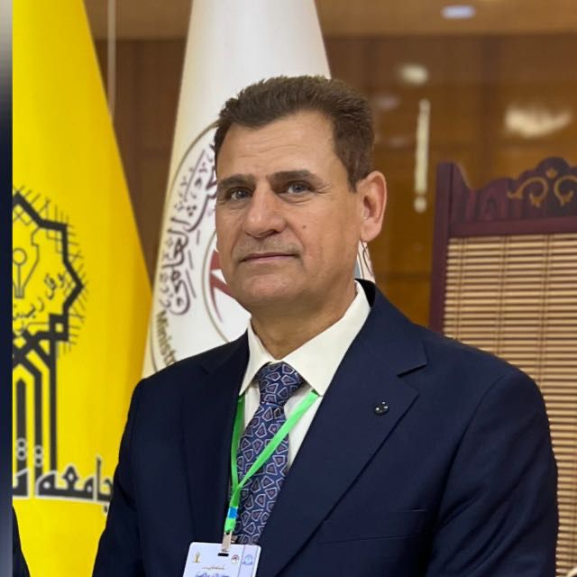
Members of the Administrative and Economic Advisory Office

- AP, Ph.D Ammar Abdul Hadi is a shallal
- AP, Ph.D Bilal Kamel Odeh
- AP, Ph.D Omar Qais Jameel
- Tarek Tohma Attia

Mission, vision and goals

Message

Providing services in various administrative, economic, accounting and statistical fields at a high level of quality and developing skills with high professionalism.

Vision

Contribute to the development of consulting work in all its fields (administrative, economic, accounting, statistical) by adopting the correct basics and in accordance with modern international standards.

Objectives of the office

- Providing consulting, services and administrative, economic and accounting expertise to the state departments and the private sector
- Exchange of experiences with similar offices and relevant authorities inside and outside Iraq
- Holding training courses for state employees and the private sector according to their needs
- Conducting statistical analyses of scientific research
- Preparing the feasibility study for new and existing economic projects to be based on correct economic scientific foundations that ensure their success

A brief overview of the office's career since its inception

The Administrative and Economic Advisory Office - Faculty of Management and Economics - was established based on the university order No. 4213 in 2009 - 5 -18, which is accompanied by the approval of the Ministry of Higher Education and Scientific Research under its letter No. 12) S/ (1189 in (26/4/2009). The office is subject to the Law of Scientific and Advisory Services Offices in institutions of Higher Education and Scientific Research No. (64) of 1979, and the Ministry's Instructions No. (40) of 1992, and then in view of developments in the advisory offices of the Ministry of Higher Education, Scientific Research and Economic Life Development in the country, Law No. (7) of 1997) and the subsequent amendments to this legislation were enacted. To facilitate the implementation of the provisions of these legislations, the Ministry issued Instructions No. (128) of (1999) and the amendments that followed

Structure of the office's board of directors

- Board of Directors (Chairman and members of the Board).
- Director of the consulting office

- The units include (the administrative unit, the accounts unit, and the relations and media unit).

Services provided by the Advisory Office

- Conducting economic feasibility studies for projects (for the public and private sector)
- Holding courses to develop the administrative and accounting staff
- Holding courses for career advancement purposes
- The work of statistical analyzes and for all scientific and humanitarian disciplines
- Auditing the final accounts of all private sector institutions
- Providing consultations in the administrative economic and accounting fields

